KAIILASH MANSAROVA YATRA
FIXED DEPARTURE – 2026: (Heli Trip) Ex Kathmandu (11 Days) 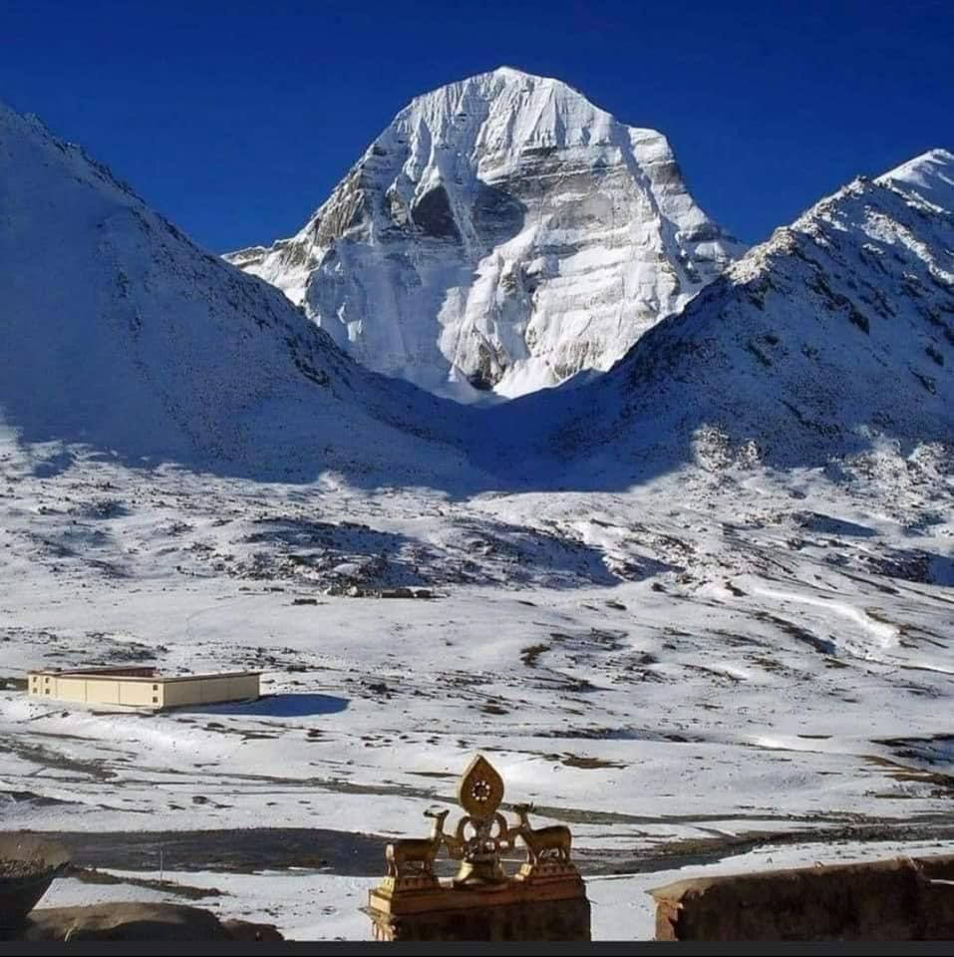

Embark on one of the most sacred pilgrimages in the world – the Kailash Mansarovar Yatra, a spiritual journey that combines breathtaking Himalayan beauty with profound cultural heritage. This divine expedition takes you through the serene landscapes of Nepal and Tibet, offering a rare chance to witness the majestic Mount Kailash (6,638 m), revered as the earthly abode of Lord Shiva, and the tranquil Lake Mansarovar, believed to cleanse the soul and wash away past sins.

The journey begins, where pilgrims acclimatize amid scenic valleys before crossing into Tibet via rugged high-altitude terrain. Each day unfolds with spectacular views of snow-clad peaks, vast plateaus, and ancient Buddhist monasteries. The highlight of the Yatra is the three-day Kora (parikrama) around Mount Kailash, a deeply spiritual walk that challenges the body but elevates the soul.

- Total Duration: 11 Days
- Max. Altitude: 5,700 meters (18,700 ft) at Dolma La Pass during the Parikrama.
- Pilgrimage Focus: Darshan of Mount Kailash, circumambulation (Parikrama/Kora) of Mount Kailash, and holy dip/puja at Lake Mansarovar.
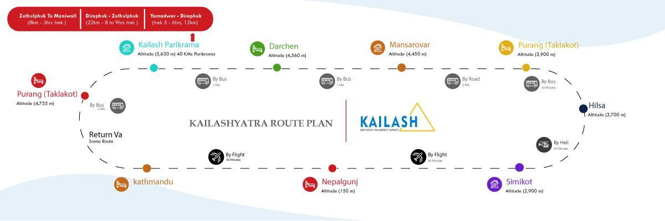
Sketch Itinerary & Altitude Profile:
Day | Route & Key Activities | Overnight at &  Altitude | Driving/Flying/Trek Time
Day 1 | Arrive Kathmandu and transfer to hotel. | Kathmandu / 3 - Star Hotel  1400Mts./4600 ft | --
Day 2 | Fly Nepalgunj to Simikot (45 min flight). | Nepalgunj/3- Star Hotel  150 m / 490 ft | Flight: 45 min
Day 3 | Fly Nepalgunj to Simikot (45 min flight). Helicopter to Hilsa (20 min). Walk & drive to Taklakot. | Taklakot (Purang) / 3 - Star Hotel  3,900 m /12,795 ft | Flight: 45 min / Heli: 20 min/Drive: 45 min  Walk: 20 min (to cross bridge)
Day 4 | Acclimatization Day in Taklakot. Free day for rest and exploring the local market. Critical for adjusting to high adjusting to high | Taklakot / 3-star Hotel  3,900 m | --
Day 5 | Drive to Lake Mansarovar (4550 m). En route see Rakshas Tal and first views of Mt. Kailash & Gurla Mandhata. Perform Mansarovar Parikrama by bus, holy dip, and puja. | LakeMansarovar / Basic Mud House  4,550 m / 14,925 ft | Drive: 1.5 hrs (90 km)  Parikrama by Bus: 3 hrs (105 km)
Day 6 | Drive to Yam Dwar. Start Kora (Parikrama) - Day 1. Trek to Diraphuk. View the West Face of Kailash. | Diraphuk / Basic Mud House  4,880 m / 16,010 ft | Drive: 1.5 hrs (43 km) / Trek: 5-6 hrs  Distance: 12 km
Day 7 | Kora - Day 2 (Most Challenging). Trek to Dolma La Pass (5700 m) and then descend to Zuthulphuk. | Zuthulphuk / Basic Mud House  4,670 m / 15,322 ft | Trek: 8-9 hrs /Distance: 22 km
Day 8 | Kora - Day 3 (Final). Short trek to Maniwall. Drive to Darchen and then back to Taklakot. Rejoin group. | Taklakot / 3-star Hotel  3,900 m | Drive: 3-4 Hrs / Trek: 3 hrs  Distance: 8 km
Day 9 | Drive to Hilsa. Helicopter  to Simikot. If possible, fly same day to Nepalgunj. | Nepalgunj / 3-star Hotel  150 m / 490 ft | Drive: 45 min / Heli: 20 min / Flight: Subject to schedule  Walk: 20 min
Day 10 | Fly to Kathmandu | Kathmandu / 3-star Hotel  1400 Mts./4600 ft | --
Day 11 | Drive to Airport. Tour  concludes. Depart for home destination. | -- | --

Kathmandu Arrival Date (2026)
*Bookings must be finalized at least 45 days before the intended travel date.
Months - 2026 | Date
May | 15, 20, 27(Full moon)
June | 02, 08, 14, 20, 26 (Full Moon)
July | 02, 08, 14, 20, 25 (Full Moon), 31
August | 06, 12, 18, 24 (Full Moon), 30
September | 05, 11, 17, 22 (Full Moon)

Itinerary (Kailash Mansarovar Yatra ex Kathmandu via Helicopter)

Day 01: Arrival Kathmandu (1400 Mts. / 4600 ft)

On Arrival at Kathmandu Airport, you will be greeted by our office representatives / driver outside of the arrival gate. Then continue to drive to the hotel evening for a short briefing about further programs & meet other members joining in your group.
Meal - Lunch if you arrive early & Dinner

Day 02: Pashupatinath Temple Darshan & Fly to Nepalgunj (150mts. / 490 ft)

After breakfast drive to Pashupatinath temple (Darshan, Perform Puja) then drive back to the hotel. Packing and preparation for yatra. In the afternoon we will drive to the domestic Airport to fly to Nepalgunj (Flight duration: 50 Mins.) Meet our representatives and drive to the hotel.
(Optional tour in Nepalgunj -You can hire taxi / cab to visit Bageshwari Temple, dedicated to Goddess Bageshwari – Durga at your own cost)
Meal - Breakfast at hotel, Lunch in Kathmandu or Nepalgunj & Dinner in Nepalgunj

Day 03: Fly to Simikot (Flight duration: 45 Mins) then fly to Hilsa (Heli duration: 20 Mins) & drive to Taklakot (3900 mts.; 45 mins. drive - 85 Km.)

In the morning we will provide packed breakfast then we will drive to the domestic airport to fly to Simikot. After a short halt in Simikot we will fly to Hilsa by chartered helicopter and wait for other members to arrive. Have Lunch in hilsa then walk for 15-20 mins.to cross bridge, after clearing formalities at Chinese check post. We’ll board an awaiting coach then drive to Taklakot (45 mins. drive).
Meal – Packed breakfast in Nepalgunj, Lunch in Hilsa & Dinner in Taklakot

Day 04: Taklakot

Entire day free for acclimatization and exploring the local market.
Meal - Breakfast, Lunch & Dinner in Taklakot

Day 05: Drive to Mansarovar Lake (4550 mts..; - 90km - 1.5 hrs. Drive)

After breakfast we will drive to Mansarovar Lake enroute visiting Raksha’s Tal (From there you can see the first view of Kailash Parbat. On the right you can view Gurla Mandhata Parbat (Barma) and continue to drive to Mansarovar Lake. After arriving at Mansarovar Lake we will do Mansarovar lake Parikrama by Bus (105 km. 03 hrs. Drive). Our team leader will take the bus to a specific spot near the lake where you can take a bath and perform puja and havan.
Meal - Breakfast in Taklakot, Lunch & Dinner in Mansarovar

Day 06: (Starting of 1st Day Kailash Parikrama) Trek to Diraphuk (4880 mts. - 12kms; 05 to 06 hrs. trek)p
After breakfast we will drive to Yamadwar (43Km - 1.5hrs drive) via Darchen. From Yamadwar you can view the south face of Kailash Parbat. This is the starting point of Parikrama. Trek 05 – 06 hrs., 12km. On the way to Diraphuk you can view the west face of Kailash Parbat on the right side.
Yatries who do not want to go to parikrama can come back to Darchen / Taklakot and wait for other members to arrive.
Yatries who cannot walk can hire horses for parikrama in Yamadwar at your own cost.
Meal - Breakfast in Mansarovar, Packed Lunch during trek & Dinner in Diraphuk

Day 07: (2nd Day of Parikrama) Trek to Zuthulphuk (4670m. 22km - 08 to 09 hrs. trek)

After breakfast, trek from Diraphuk to Dolma La pass (5700m.). This is the most difficult journey throughout the yatra since you have to trek up to 18,600 ft. About 3km before reaching Dolma La Pass is a steep hill and quite difficult to walk. Also descending from Dolma La Pass is the same for up to 3km (You can see Gaurikund on the right) then continuing the trek to Zuthulphuk.
Meal – Breakfast in Diraphuk, Packed Lunch during trek & Dinner in Zuthulphuk

Day 08: (Ending Day of Parikrama, 8 Km - 3 hrs. trek) Trek to Darchen & Drive to Taklakot

After breakfast, a short trek to Maniwall (8 km - 3hrs trek). Our Coach will pick you from there then we will drive to Darchen (3 km.) and merge with other members who are waiting for us to complete parikrama and continue drive back to Taklakot
Meal – Breakfast in Zuthulphuk, Lunch in Darchen & Dinner in Taklakot

Day 09: Drive back to Hilsa (3700m.) & Fly to Simikot (2900m.)

After breakfast we will drive to the check point then have a short walk to cross the bridge to get to the hilsa. Then take a helicopter to fly to Simikot.
(From Simikot we will try to fly Nepalgunj on same day; it depends on flight schedule)
Meal – Breakfast in Taklakot, Lunch in Hilsa / Simikot & Dinner in Simikot / Nepalgunj

Day 10: Fly back to Kathmandu or Drive to Lucknow

After breakfast, drive to the domestic airport to fly to Kathmandu. Pick up from Kathmandu Airport then drive to the hotel.
Meal – Breakfast in Nepalgunj, Lunch & Dinner in Kathmandu

Day 11: Departure

After breakfast drive to Kathmandu International Airport to move towards your own destinations
Meal – Breakfast

Currency in Tibet: The Chinese Yuan (CNY). Can be exchanged from a bank or local money changers.

Package Includes:
- Arrival/departure transfers from airport to hotel as per program.
- All accommodation as per itinerary Kathmandu/Nepalgunj/Taklakot & Darchen based on double/triple sharing basis & Rest on 04 to 06 sharing basis01 Night accommodation in Nepalgunj 3-star hotel- Double sharing.
- Sightseeing of Pashupatinath Temple in Kathmandu.
- Chartered helicopter (Simikot-Hilsa both ways).
- Full Board Veg. Meal (In Nepal side hotel meals & In Tibet side our staff will be there to prepare meal).
- Luxury coach transport in Tibet.
- Nepali Team leader and supporting team.
- English speaking Tibetan guide.
- Chinese visa.
- Permit fee.
- Humla Restriction fee.
- 01 Duffel Bag, 01 Day Pack (Small Shoulder Bag) and 01 Jacket.
- Oxygen cylinder (Medical Purpose Carried by Our Sherpa Team)

Package Excludes:
- GST Extra.
- Home-Kathmandu-Home Airfare.
- Cost for extra night accommodation.
- Horse Ride or Porter during Parikrama.
- Evacuation cost.
- Travel insurance & Expenses of personal nature etc.
- Visa splitting Charge & Extra transport cost, if returning early from Tibet.
- Tips for Nepali Sherpa/Chinese Team @ CNY 200
- Any extra services which are not mentioned.

Booking Requirements & Procedure:

1. Passport Validity: Must be valid for at least 6 months from the date of travel.
2. Passport Pages: Must have a minimum of 2 blank pages.
3. Existing Visa: Any existing valid Chinese visa in the passport must be cancelled before travel.
4. Process:
  - Submit an advance booking amount along with a Xerox copy of your passport.
  - Submit your original passport to the Delhi office 10-15 days before travel for visa processing.

Cancellation Policy

- After Booking: INR 25,000 is non-refundable.
- 20 days before departure: 50% of the total trip cost.
- 15 days before departure: 90% of the total trip cost.
- 10 days or less before departure: 100% of the total trip cost.
- All cancellations must be sent in writing; verbal cancellations are not accepted.

Critical Risk Acknowledgement (As per Operator)
Before booking, Yatries must understand and accept the following:

- The operator is not responsible for accidents or delays in evacuation due to natural calamities in the remote terrain.
- The operator is not liable for any illness due to the hazards of high-altitude travel where emergency treatment is unavailable.
- No refunds will be issued for changes or cancellations imposed by Chinese authorities or other factors beyond the operator's
- control.
- This is a physically demanding and high-risk journey. Yatries undertake this travel entirely at their own risk.

Note - The Tour Operator or any of its partners shall not be held responsible/liable for any change/delay in the schedule due to weather
Any extra cost incurred has to be paid by the clients.

Essential Packing List & Guidelines

- Clothing (No Sarees): Indian women pilgrims are strictly advised not to wear sarees.
- Must-Haves: Good quality hiking shoes, woollen thermals, warm trousers, woollen shirts, sweater/jacket, raincoat, woollen cap, gloves, woollen socks.
- Gear: Walking/hiking sticks, torch/flashlight, water bottles, toilet paper, sunglasses, sunscreen (high SPF), towel.
- Medicines: Personal prescriptions and Diamox (for altitude sickness-consult a doctor for dosage).
- Snacks: Energy-giving food like chocolates, dry fruits, toffees, and glucose.

Health Advisory & Altitude Warning

- Fitness Level: This is one of the toughest high-altitude journeys. You must be in excellent physical health.
- Medical Check-Up: A thorough check-up by your doctor is mandatory, especially for those with pre-existing heart or respiratory conditions like asthma.
- Altitude Sickness: Symptoms like headache, nausea, loss of appetite, and breathlessness are common. The acclimatization day in Taklakot is crucial.
- Precautions: Drink 3-4 liters of water daily, avoid alcohol and smoking, do not over-exert, and inform your guide immediately of any severe symptoms.

Risks & Liability

Travel Company and its associates will put every effort into making your journey smooth and pleasant. However, all the tours in Tibet are conducted strictly under the rules & regulation of Tibet Tourism Bureau (TTB). Therefore, Travel Company and its counterpart shall not be responsible for any change and alteration in the program due to unavoidable circumstances such as landslide, road blockage, flood, snow, political unrest, cancellation of flight, delay arrival, delay issue of permit and visa, sickness or accidents. Any extra cost incurred thereof shall be borne by the clients on the spot.

India Office: Monks & Monkeys Travels (New Delhi, India) Phone: + 91 9310763436

Please Note: Package price may increase if any changes occur in fuel prices / others due to the prevailing war situation. Any such increase in operational costs will be borne by the traveler.

